**KEBUTUHAN DATA PELAPORAN RENCANA PENGEMBANGAN TI /RPTI (COMPLIANCE OJK)**

|  |  |  |
| --- | --- | --- |
| No |  | Detail Kebutuhan data |
| 1 | **Nama Aplikasi/Infras** | **Nama aplikasi/infras yang akan dikembangkan (list di tabel III)** |
| 2 | **Deskripsi** | Detail pengembangan Aplikasi/Infras  Deskripsi atas rencana pengembangan terhadap aplikasi/infras terkait |
| 2 | **Kategori** | 1. **Pengelolaan Nasabah** 2. **Dana Pihak ketiga (Giro, Tabungan, Deposito)** 3. **Perkreditan/Pembiayaan** 4. **Buku Besar (GL)** 5. **Pembayaran** 6. **Layanan Perbankan Elektronik** 7. **Tresuri** 8. **Pembiayaan Perdagangan (Trade Finance)** 9. **APU dan PPT** 10. **Manajemen Sistem Informasi** 11. **Manajemen risiko** 12. **Manajemen Intern** 13. **Aplikasi lainnya** 14. **DC/DRC** 15. **Server dan/atau platform** 16. **Jaringan Komunikasi data** 17. **Sistem Keamanan (Security System)**   **(99) Infrastruktur lainnya** |
| 3 | **Jenis Pengembangan** | 1. **Baru**  (jika aplikasi/infras baru/menggantikan yang lama 2. **Upgrade** (jika penambahan/pengembangan dari aplikasi/infras yg telah ada) |
| 4 | **Pengembangan** | 1. **Inhouse** 2. **PPJTI (Pihak Penyedia Jasa TI)** |
| 5 | **Pihak Penyedia Jasa TI Pihak terkait** | 1. **Ya** , jika PPJTI pihak terkait Bank 2. **Tidak,** jika PPJTI bukan pihak terkait 3. **“-“** jika pengembangan dilakukan secara inhouse atau PPJTI belum ditetapkan |
| 6 | **Lokasi DC/DRC** | **DC** : Nama Kota Lokasi DC (Jakarta, London, Tokyo)  **DRC** : Nama Kota Lokasi DRC (Purwakarta) |
| 7 | **Waktu Rencana Implementasi** | **TW1, TW2, TW3, TW4** |
| 8 | **Estimasi Biaya Capex/Opex** | **Estimasi Capex dan / atau Opex selama** 1 (satu) tahun sejak implementasi (tidak termasuk by penyusutan Capex), dlm Rp |
| 9 | **Keterangan** | Dampak pengembangan, terkait RBB, dll |

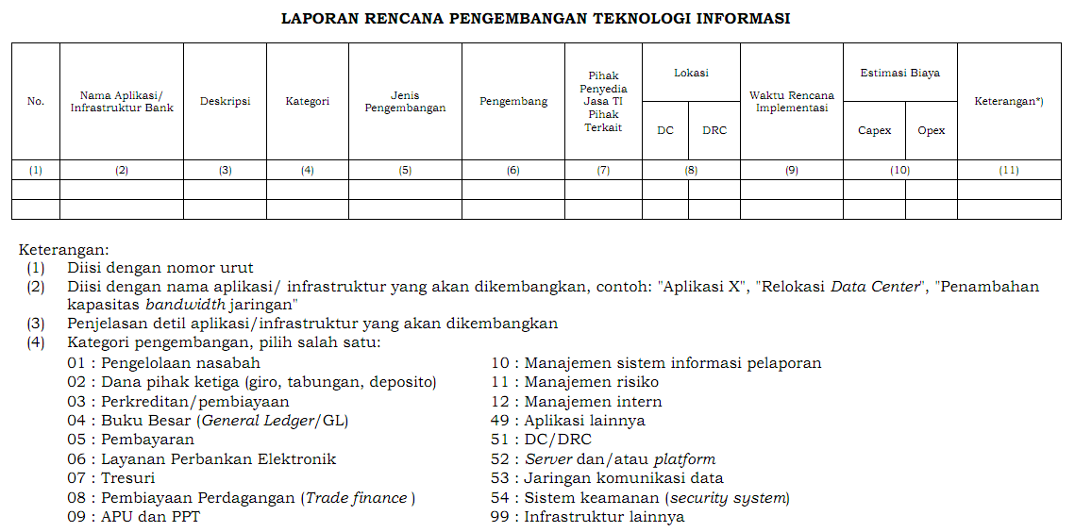

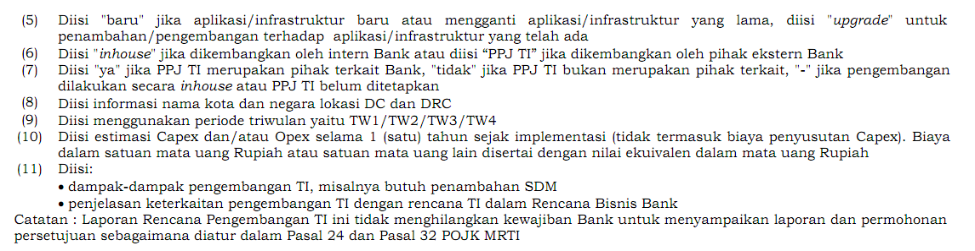

**KEBUTUHAN DATA UNTUK PELAPORAN PROFILE RISIKO (ERM & OJK)**

Periode data :

Bulanan : Laporan (Internal Rating Risk/IRR) setiap tgl 15 bulan ke Dir MR

Triwulan : Laporan Profile Risiko BNI ke OJK, setiap tgl 10

Semester : Laporan Tingkat Kesehatan Bank (TKB) ke OJK, setiap tgl 10

|  |  |  |  |
| --- | --- | --- | --- |
| No | Parameter | Keterangan | Data needed |
|  | **Kompleksitas Sistem TI** | 1. Aspek Kastemisasi :   % Aplikasi Agile/Non Agile | **Mekanisme Pengembangan aplikasi :**   1. **Agile** 2. **Non Agile** |
|  |  | 1. Aspek IT Landscape Size :   % Pengembangan Aplikasi Digital | **Jenis Aplikasi :**   1. **Digital** 2. **Non Digital** |
|  | **Perubahan Sistem TI** | 1. % Promosi Aplikasi Tk Mayor | **Risiko Promosi :**   1. **Minor** 2. **Mayor** |
|  |  | 1. % Promosi Aplikasi Digital | Jumlah aplikasi digital yang dipromosikan dari keseluruhan (total) jumlah aplikasi yang dipromosikan |
|  | **Kerentanan Sistem TI** | 1. % Deteksi ancaman & serangan TI pada perimeter security TI |  |
|  |  | 1. % Deteksi ancaman & serangan TI pada pengguna TI |  |
|  | **Maturity TI** | Score IT Maturity |  |
|  | **Kegagalan Sistem** | 1. % Downtime Aplikasi Severity 1 |  |
|  |  | 1. % Downtime Layanan Aplikasi Digital |  |
|  | **Kehandalan Infras Pendukung** | 1. % Downtime Jarkom ATM |  |
|  |  | 1. % Downtime Jarkom Outlet (Wil.Cab/Sentra) |  |

**Metode perhitungan Profile Risiko TI**

Parameter :

1. Kompleksitas Sistem TI
2. Aspek Kastemisasi (% Agile/Non Agile)

% Agile (menurut ERM) diambil dari jumlah pengembangan aplikasi digital (misal enhancement Reksa Dana online di mobile banking dihitung 1 aplikasi). Definisi agile adalah aplikasi yang termasuk ke dalam kriteria aplikasi Digital (termasuk fitur), produk baru dan ada di RBB/ ITSP. Diambil dari jumlah fitur/project pengembangan agile/digital yang beresiko.

|  |  |  |  |
| --- | --- | --- | --- |
| **No** | **Parameter** | **Keterangan** |  |
| **1** | **Aplikasi Agile/Digital** | 1. **ATM** 2. **Mbank** 3. **EDC android** 4. **Sonic** 5. **API** 6. **My Card** 7. **Virtual Assisstant** 8. **Agen46** 9. **Bni Direct Mobile** 10. **e-collection** 11. **GB Online** 12. **Digital Loan** 13. **BNI Mobile Remittance (MoRe)** 14. **Digi Sales** |  |
| **2** | **Mekanisme Pengembangan** | 1. **Agile** 2. **SDLC** 3. **Mini SDLC** |  |
|  |  |  |  |
| **3** | **Jenis Aplikasi** | 1. **Digital** |  |
|  |  | 1. **Non Digital** |  |

**TABEL III**

|  |  |  |
| --- | --- | --- |
| **No** | **Aplikasi** | **Kelompok Dev** |
| No | **LIST APLIKASI** |  |
| 1 | Account Maintenance |  |
| 2 | ACPS |  |
| 3 | ADK Net |  |
| 4 | Agen46 |  |
| 5 | Agenda Direksi |  |
| 6 | Agent46 Mobile |  |
| 7 | AML (Anti Money Laundry) |  |
| 8 | API Management |  |
| 9 | Aplikasi Data Penerima Kuasa |  |
| 10 | Aplikasi Monitoring Financial Cabang |  |
| 11 | Aplikasi Monitoring Pagu Kas (SISKA) |  |
| 12 | Aplikasi Otomasi Pembukuan |  |
| 13 | Aplikasi Referral Taplus Bisnis |  |
| 14 | Aplikasi Refund Online (CCMS) |  |
| 15 | Aplikasi Rehabilitasi DHN |  |
| 16 | Aplikasi Undian |  |
| 17 | Audit Management System (AMS) |  |
| 18 | Awareness and Supervision Report (ASR) |  |
| 19 | Bancslink |  |
| 20 | Bank Guarantee Mobile Checking |  |
| 21 | Base 24 |  |
| 22 | BB Online |  |
| 23 | BCC |  |
| 24 | BI-SSSS |  |
| 25 | Big Data |  |
| 26 | Biller / Switcher |  |
| 27 | Billing Payment System (BPS) |  |
| 28 | Biometrik |  |
| 29 | BND |  |
| 30 | BNI ATM View (BAV) |  |
| 31 | BNI Call Virtual Assistant |  |
| 32 | BNI Control Overview (BCO) |  |
| 33 | BNI Direct - Primecash |  |
| 34 | BNI Forum |  |
| 35 | BNI Instan |  |
| 36 | BNI Kustody Account Registry & Settlemet (BaRS) |  |
| 37 | BNI Move |  |
| 38 | BNI Outlet & ATM |  |
| 39 | BNI Poin Plus |  |
| 40 | BNI Recruitment Online (E-recruitment) |  |
| 41 | BNI SMART |  |
| 42 | BNI Smart Trade Portal (BSTP) |  |
| 43 | BNI Smarter |  |
| 44 | BNI Trade Online |  |
| 45 | Branch Navigation |  |
| 46 | Business Activity Monitoring System (BAMS) |  |
| 47 | Call Register |  |
| 48 | Cardlink |  |
| 49 | CDMS (Collateral Document Management System) |  |
| 50 | CelenganQu |  |
| 51 | Chatbot (Leva, WA Business, Virtual Assistant) |  |
| 52 | China Union Pay |  |
| 53 | CityNet |  |
| 54 | CLPS (Credit Loss Prevention System) |  |
| 55 | CMOD |  |
| 56 | CMS (Contain Management System) |  |
| 57 | Collection Call Register |  |
| 58 | Collection Monitoring |  |
| 59 | Combined Statement |  |
| 60 | Common Collection |  |
| 61 | Compliance Information Management System (CIMS) |  |
| 62 | Contactless Payment |  |
| 63 | Corporate Website |  |
| 64 | Counterpart Business Analytic (CBA) |  |
| 65 | Customer Profitability Report (CPR) |  |
| 66 | Credit Card Origination System (CCOS) |  |
| 67 | CSMT (Corporate Strategy Management Tools) |  |
| 68 | Custody System |  |
| 69 | CWX |  |
| 70 | Dana Pensiun Lembaga Keuangan (DPLK) |  |
| 71 | Dashboard Agen |  |
| 72 | Dashboard Hukum |  |
| 73 | Dashboard Kartu |  |
| 74 | Data Jaminan |  |
| 75 | Debitur Di Tolak (3D) |  |
| 76 | Development Tool Monitoring ATM berbasis Agent (Agent Base) |  |
| 77 | Digi Teller |  |
| 78 | Digibond |  |
| 79 | DigiHC |  |
| 80 | DigiHome |  |
| 81 | Digimap |  |
| 82 | DigiMudik |  |
| 83 | Digipayroll |  |
| 84 | Digisales |  |
| 85 | Digital Banking Loan Processing |  |
| 86 | Digital Credit Services (DCS) |  |
| 87 | Digital Opening Account (DOA) |  |
| 88 | Digital Onboarding Akuisisi Merchant |  |
| 89 | DigiTani |  |
| 90 | Document Mgmt. System (DMS) |  |
| 91 | Domain Controller |  |
| 92 | e-Bank Guarantee |  |
| 93 | e-Cash Supply |  |
| 94 | e-Catalogue |  |
| 95 | e-Dapem (Daftar Pembayaran) |  |
| 96 | E-Form |  |
| 97 | e-Form Monitoring |  |
| 98 | e-Form Simpanan |  |
| 99 | e-LO |  |
| 100 | E-Office |  |
| 101 | E-PAK (Perangkat Aplikasi Kredit) |  |
| 102 | e-PK (Perjanjian Kredit) |  |
| 103 | e-PP (Pedoman Perusahaan) |  |
| 104 | E-Procurement |  |
| 105 | E-Purse |  |
| 106 | e-Rumjab (Rumah jabatan) |  |
| 107 | E-Statement |  |
| 108 | Early Warning System (EWS) |  |
| 109 | ECMS (Enterprise Card Management System) |  |
| 110 | EDC |  |
| 111 | EDC Care |  |
| 112 | EDWH |  |
| 113 | Electronic Absensi (E-Absensi) |  |
| 114 | Electronic Loan Gurantee / Penjaminan KUR |  |
| 115 | eLog |  |
| 116 | Email Blast |  |
| 117 | Employee Volunteering |  |
| 118 | Enterprise Audit Management System (EAMS) |  |
| 119 | Enterprise Fraud Management (EFM) |  |
| 120 | EWS Mobile |  |
| 121 | Finance One (F1) |  |
| 122 | Fixed Asset Management |  |
| 123 | Flex Loan |  |
| 124 | FLPP H2H |  |
| 125 | Foreign Exchange Machine (FEM) |  |
| 126 | Front End FTP (Fund Transfer Pricing) ALMA |  |

|  |  |  |
| --- | --- | --- |
| 127 | FSCM (Financial Supply Chain Management) |  |
| 128 | Fund Valuation & Transfer Agency |  |
| 129 | Gateway |  |
| 130 | Giro Wajib Minimum (GWM) |  |
| 131 | Global File Exchange (GFX) |  |
| 132 | GLOBS |  |
| 133 | Go Remit |  |
| 134 | Go Trade |  |
| 135 | Go Trust |  |
| 136 | Go VAR |  |
| 137 | Go Wealth |  |
| 138 | Golden Gate |  |
| 139 | GPN (Gerbang Pembayaran Nasional) |  |
| 140 | GRIPS (Gathering Reports & Information Processing System) Client |  |
| 141 | HCMS Mobile |  |
| 142 | Human Capital Management System (HCMS) |  |
| 143 | Human Capital System (Hucas) |  |
| 144 | iBank Remitt |  |
| 145 | IBOC |  |
| 146 | ICONIC |  |
| 147 | ICONS |  |
| 148 | IDEAS (Integrated Decision Automated System) |  |
| 149 | Identity Management |  |
| 150 | Implementasi E-Statement BNI Emerald |  |
| 151 | Infrastruktur |  |
| 152 | Instan Appraisal UMG |  |
| 153 | Integrated Human Capital System (IHCS) |  |
| 154 | Internet Banking |  |
| 155 | Inventory Management System (IMS) |  |
| 156 | IVR Tele Collection |  |
| 157 | Japan Desk Performance |  |
| 158 | K+TP |  |
| 159 | Kastle |  |
| 160 | Keagenan |  |
| 161 | KKPKP Online |  |
| 162 | Kondor Global Risk (KGR) |  |
| 163 | Kondor+ |  |
| 164 | KTP Adapter |  |
| 165 | Lalu Lintas Devisa (LLD) |  |
| 166 | Laporan bulanan Bank Umum (LBU) |  |
| 167 | LBU2008 |  |
| 168 | Lelang Agunan |  |
| 169 | MIDAS |  |
| 170 | MIMIC |  |
| 171 | MIS Portal: EIS, PMS, CRM, SRP, BAR (SAR), KIS, IRS |  |
| 172 | Mobile Banking Rich Client |  |
| 173 | MPN (Modul Penerimaan Negara) |  |
| 174 | MTelePlus |  |
| 175 | MyCard |  |
| 176 | New Brainbox |  |
| 177 | O-Branch |  |
| 178 | Omni Channel |  |
| 179 | Online Assessment Pegawai |  |
| 180 | Online Customer Complaint (OCC) |  |
| 181 | Online Request Management (ORM) |  |
| 182 | OPAC (Pencatatan Absensi dan Cuti) |  |
| 183 | Opening Account Alert System (OASE) |  |
| 184 | Otomasi Anggaran Investasi |  |
| 185 | Otomasi Kewenangan Aplikasi BNI (OKAB) |  |
| 186 | Otomasi Pajak |  |
| 187 | Otomasi Penerbitan Bank Garansi (OPBG) |  |
| 188 | Otomasi Perintah Buku Kredit (OPBK) |  |
| 189 | PACE (Package of Accurate Convenient Efficient Recasting) |  |
| 190 | PERISKOP (Perangkat Risiko Operasional) |  |
| 191 | Perjalanan Dinas - Travel Card |  |
| 192 | Persekot (Transitoris) |  |
| 193 | PIN Mailerless |  |
| 194 | PKU Mobile |  |
| 195 | PlafonGB |  |
| 196 | Planning & Budgeting |  |
| 197 | Portal Asset Management Div RRM RRC |  |
| 198 | Portal Dashboard PPA |  |
| 199 | Portal Sindikasi |  |
| 200 | Portal Tresuri Bank Notes |  |
| 201 | Predictive Dialer System (PDS) |  |
| 202 | Prognosis |  |
| 203 | PSAK - Finstudio |  |
| 204 | PVCS |  |
| 205 | Remedy |  |
| 206 | RERE (Remedial & Recovery) |  |
| 207 | Resource Access Control Facility (RACF) |  |
| 208 | RMIS (Risk Monitoring Information System) |  |
| 209 | RPA (Robotik Processing Automation) |  |
| 210 | RRM Asset Management |  |
| 211 | RTGS |  |
| 212 | S-Invest |  |
| 213 | Sales Activity & Performance Management (SAPM) |  |
| 214 | SAPM - BIN on the Go |  |
| 215 | SAS EIP |  |
| 216 | SDB |  |
| 217 | Self Service Opening Account (BNI Sonic) |  |
| 218 | Sentra Kas ATM (SKA) |  |
| 219 | SID Otomasi |  |
| 220 | SIKP |  |
| 221 | Single Point of View (SPV) |  |
| 222 | Sistem Alat Bantu Analisa Kredit (SABAK) |  |
| 223 | Sistem Informasi Bina Lingkungan BNI (SIMBL) |  |
| 224 | Sistem Informasi Pelaporan Perkara (SIPP) |  |
| 225 | Sistem Monitoring Audit (SiMona) |  |
| 226 | Sistem Monitoring Pemeliharaan Merchant (SMPM) |  |
| 227 | Sistem Monitoring Proses Kredit (SMPK) |  |
| 228 | Sistem Otomasi Proyeksi Cashflow (BNI OPTIC) |  |
| 229 | Sistem Proses Monitoring Kredit (SMPK) |  |
| 230 | SKCDM |  |
| 231 | Smart CA |  |
| 232 | Smart Digital System (SDS) |  |
| 233 | Smart Forex |  |
| 234 | Smart Queuing System (SQS) |  |
| 235 | Smart Remitance |  |
| 236 | Smart Terminal Peserta Kliring |  |
| 237 | SMS Banking |  |
| 238 | SOA System |  |
| 239 | Social Media Care BNI |  |
| 240 | SPRINT |  |
| 241 | STPK-SKNBI |  |
| 242 | Survey Online |  |
| 243 | SVS |  |
| 244 | Sweep Account |  |
| 245 | SWIFT ALLIANCE |  |
| 246 | Tactical Account Planning (TAP) |  |
| 247 | Tactical Sales Tools (TST) |  |
| 248 | Talent Management Application |  |
| 249 | Tapcash Go |  |
| 250 | Telemarketing |  |
| 251 | Telepac |  |
| 252 | TI Plus |  |
| 253 | Trade App Supporting System (TASS) |  |
| 254 | Underlying Transaksi Valas |  |
| 255 | UnikQu |  |
| 256 | Verifikasi SKB |  |
| 257 | Virtual Assistant Sales |  |
| 258 | Virtual EDC |  |
| 259 | Walk In Customer (WIC) |  |
| 260 | Wallet Account |  |
| 261 | Wealth Management System (WMS) |  |
| 262 | Website Lelang |  |
| 263 | WhatsApp Business |  |
| 264 | XDI |  |
| 265 | Yap! |  |

**IT GOV Project Management:**

**Tracking**

1. Dapat mengidentifikasi project2 apa saja yang termasuk ke dalam laporan RPTI awal
2. Dapat mengidentifikasi project2 apa saja yg merupakan insertion (tidak termasuk ke dalam laporan RPTI awal)
3. Dapat mengidentifikasi project2 yang termasuk ke dalam kategori RBB, audit,government,itsp
4. Dapat mengidentifikasi project2 yang merupakan kriteria agile
5. Dapat mengidentifikasi project2 yang merupakan Digital Banking
6. Dapat mengindentifikasi project2 yang mekanisme pengembangannya dg Agile/SDLC/Mini SDLC

**Monitoring**

1. Dapat memonitor status project yang termasuk di dalam laporan RPTI dan yg insertion
2. Dapat memonitor status progress project (CR/IR) yang kategorinya sbg fup atas temuan audit/perbaikan problem

**Reporting**

1. Otomasi Laporan Rencana Pengembangan TI (RPTI)
2. Otomasi Revisi Laporan Rencana Pengembangan TI (Revisi RPTI)
3. Otomasi Laporan Profil Risiko TI